Capitol Information & Education Virtual Day of Action
Raising Our Voices Against Tobacco
All Social Media Materials and Posts
The California Tobacco Endgame Center for Organizing and Engagement
A Project of the American Heart Association
2007 O Street | Sacramento | CA | 95811
OrganizingToEndTobacco.org
© 2020
California Department of Public Health.
Funded under contract # 19-10090

Contents
Social Media: Pre-Virtual Day of Action Posts 1
Social Media: Virtual Day of Action – Day-of ‘Call to Action’ Themes 3
African American Population 4
Asian Americans, Native Hawaiians, and Pacific Islanders Population 5
Environmental 6
Hispanic/Latino Population 7
LGBTQ Population 8
Rural Communities 10
Californian Women 11

Social Media: Pre-Virtual Day of Action Posts

Post #1 Theme: California has come a long way in the fight against tobacco use – but there is still more work to be done.
We’ve come a long way in our fight against #Tobacco, we can’t stop now.  Learn more: organizingtoendtobacco.org/  #VoicesAgainstTobacco | 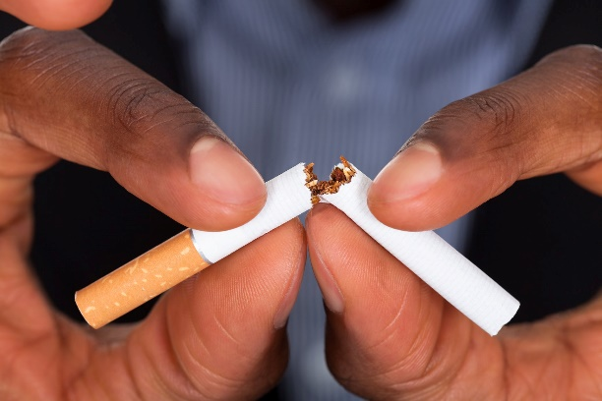
Post #2 Theme: Tobacco disproportionately impacts communities of color and the poor.
Tobacco industry targeting of communities of color increases disparities in health, disease and death.
Learn more: organizingtoendtobacco.org
#VoicesAgainstTobacco

Post #3 Theme: We’re fighting a deadly public health pandemic, while the teen vaping epidemic goes on.
Youth vaping is an epidemic sponsored by the #Tobacco industry.
Learn more: organizingtoendtobacco.org
#VoicesAgainstTobacco

Post #4 Theme: COVID-19 and tobacco are a deadly combination.
COVID-19 & Tobacco – a deadly combination for our lungs. Join the fight!  Learn more: organizingtoendtobacco.org  #VoicesAgainstTobacco | 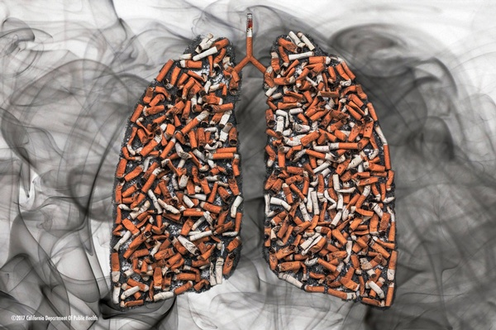

Social Media: Virtual Day of Action – Day-of ‘Call to Action’ Themes

  - Social Media Messaging by Priority Population

African American Population
Tobacco industry targeting of communities of color increases disparities in health, disease and death. African American tobacco users are more likely to die from smoking- related illness than white tobacco users, despite smoking fewer cigarettes. Learn more: organizingtoendtobacco.org  #VoicesAgainstTobacco | 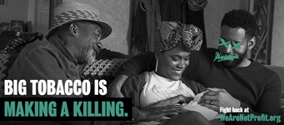
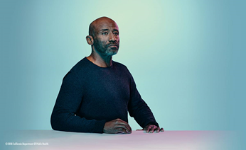 | Tobacco industry targeting of communities of color increases disparities in health, disease and death. African American tobacco users are more likely to die from smoking- related illness than white tobacco users, despite smoking fewer cigarettes. Learn more: organizingtoendtobacco.org  #VoicesAgainstTobacco

  - Social Media Messaging by Priority Population

Asian Americans, Native Hawaiians, and Pacific Islanders Population
Tobacco-related cancer and cardiovascular disease are the top two causes of death for Asian Americans, Native Hawaiians, and Pacific Islanders. Raise your voice against the tobacco products that are damaging our community!  Learn more: organizingtoendtobacco.org  #VoicesAgainstTobacco | 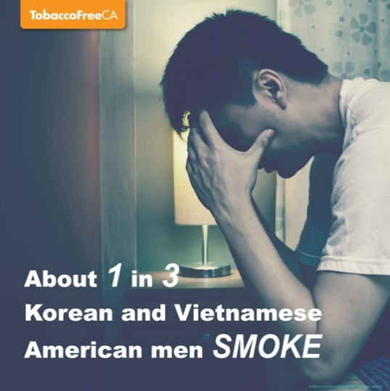
While we’re fighting a deadly pandemic, there is a teen vaping epidemic in California. Big Tobacco targets Asian American, Native Hawaiian, and Pacific Islander youth through e-cigarette flavors like lychee, taro, and passion fruit.  Learn more: organizingtoendtobacco.org  #VoicesAgainstTobacco | 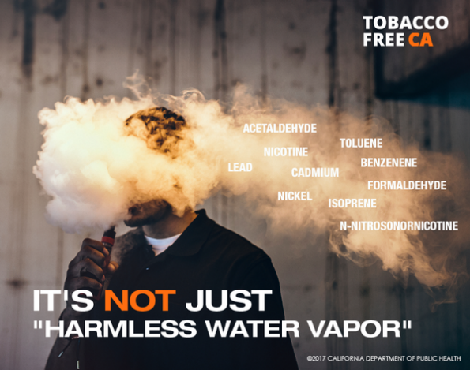

  - Social Media Messaging by Priority Population

Environmental
Raise your voice against Big Tobacco that is actively trashing our environment and homes. Tobacco litter pollutes by releasing chemicals including arsenic and lead.
Learn more: organizingtoendtobacco.org
#VoicesAgainstTobacco

Your environment needs you to raise your voice against Big Tobacco: our precious aquatic ecosystems are littered with cigarette butts and polluted with deadly chemicals.
Learn more: organizingtoendtobacco.org
#VoicesAgainstTobacco

  - Social Media Messaging by Priority Population

Hispanic/Latino Population
In CA, 10.3% of Hispanic/Latino youth use tobacco with the majority choosing a vaping device as their product of choice. Raise your voice against Big Tobacco to protect Hispanic/Latino youth from a lifetime of addiction.
Learn more: organizingtoendtobacco.org
#VoicesAgainstTobacco
Raise your Voice to Kick Big Tobacco out of our Hispanic/ Latino communities, which have a higher density rate of tobacco retailers – almost 26% higher than the general population. Stand up and tell them ‘Not in my community’!
Learn more: organizingtoendtobacco.org
#VoicesAgainstTobacco

  - Social Media Messaging by Priority Population

LGBTQ Population
Tobacco disproportionately impacts the LGBTQ community. LGBTQ youth start using tobacco earlier and use tobacco at higher rates compared to heterosexual youth. Raise your voice in support of our vulnerable youth.  Learn more: organizingtoendtobacco.org  #VoicesAgainstTobacco #WeBreathe | 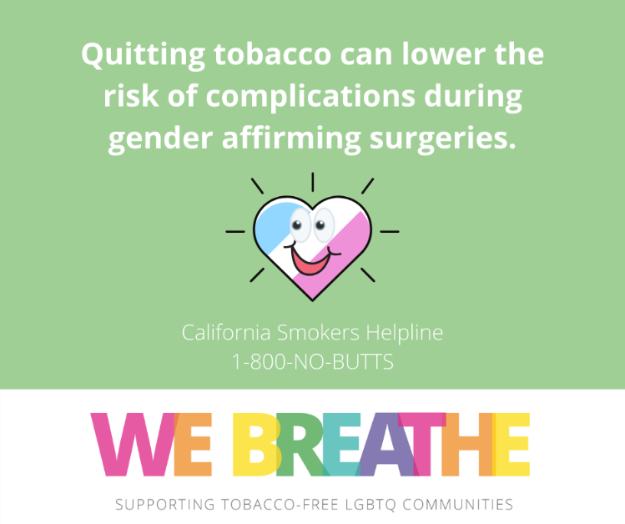

Raise your voice against tobacco-industry marketing tactics which aggressively targets the LGBTQ community contributing to high rates of tobacco use.  Learn more: organizingtoendtobacco.org  #VoicesAgainstTobacco #WeBreathe | 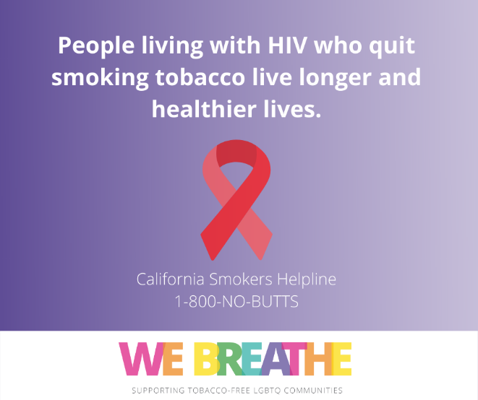
This #Pride Month, we urge our legislative leaders in @calgbt to be partners in ending #LGBTQ tobacco-related disparities so that all our communities can thrive and live long, healthy lives. Learn more at:  organizingtoendtobacco.org  #VoicesAgainstTobacco #WeBreathe | 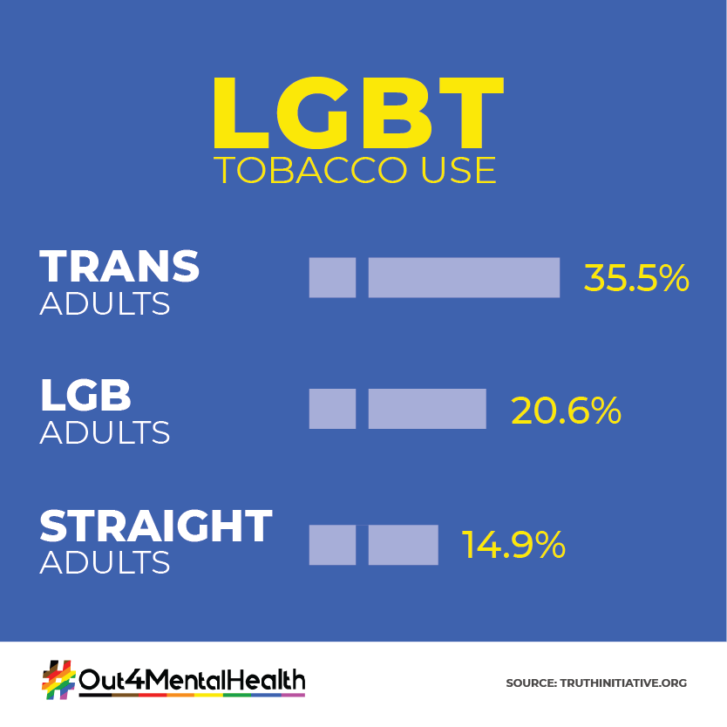

  - Social Media Messaging by Priority Population

Rural Communities
Rural youth are 3x more likely to smoke than other youth. Raise your voice to support rural communities and families in the fight against Big Tobacco.  Learn more: organizingtoendtobacco.org  #VoicesAgainstTobacco | 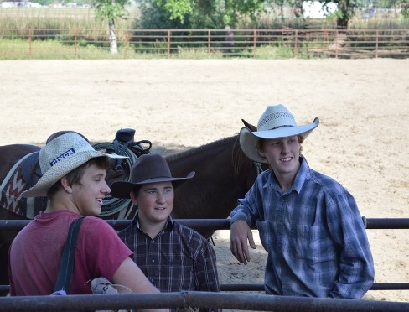
Rural adults’ use of any tobacco product is higher than adults in other areas. Raise your voice to support rural communities and families in the fight against Big Tobacco.
Learn more: organizingtoendtobacco.org
#VoicesAgainstTobacco

  - Social Media Messaging by Priority Population

Californian Women
Big Tobacco has been targeting women for nearly a century. As a result, more than 200,000 women die each year in the U.S. as a result of smoking- related diseases. This needs to stop now!  Learn more: organizingtoendtobacco.org  #VoicesAgainstTobacco | 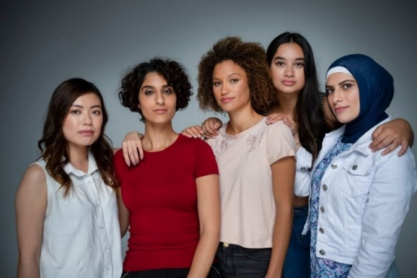
Women who smoke have a 25% greater risk of developing coronary heart disease compared with men who smoke. Raise your voice against the tobacco products and marketing that are breaking our communities’ and families’ hearts! [insert breaking heart emoji]
Learn more: organizingtoendtobacco.org
#VoicesAgainstTobacco

